Anthony Rusignuolo

CS 600WS – Advanced Algorithms

Reza Peyrovian

Homework 12

I pledge my honor that I have abided by the Stevens Honor System.

1. R-26.3 Suppose that instead of maximizing hits per minute, constraints, a web server company wants to minimize cost while maintaining a rack of standard and cutting-edge servers that can handle at least 15,000 hits per minute. Also, for the sake of redundancy, the company wants to maintain at least 10 servers in their rack. Based on these constraints, give a linear program to ﬁnd the optimal server con-ﬁguration. Draw the feasible region, and solve the LP geometrically.
   1. Minimize: $z=400x_{1}+1600x_{2}$ Subject To: $1000x_{1}+2000x_{2}<36800$ $$2x_{1}+x_{2}≤44 \\ x_{1}+x_{2}≥10 \\ 300x_{1}+500x_{2}≤12200 \\ x_{1}, x_{2}≥0$$ 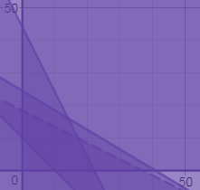  
      The darkest purple region is the feasibility region.
2. R-26.7 For each of the regions shown in Figure 26.8, give an LP for which that region is the feasible region, or explain why no such linear program exists.  
     
   a.  
   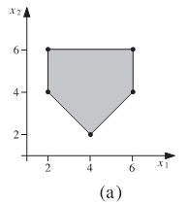  
   b.  
   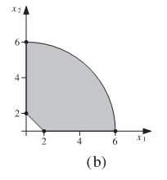  
   c.  
   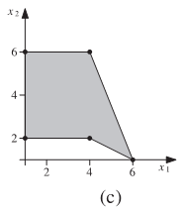  
   1. a. $$x_{2}≤6 \\ x_{1}≥2 \\ x_{1}≤6 \\ x_{1}+x_{2}≥6 \\ -x_{1}+x_{2}≥-2$$  
      b.  
       The graph is not an example of linear programming because it has a curve  
        
      c.  
       The graph is not an example of linear programming because it is not convex.
3. R-26.10 For each vertex, (3,9) and (8,6), of the feasible region shown in Figure 26.9, give an objective function that has that vertex as the optimal solution.  
   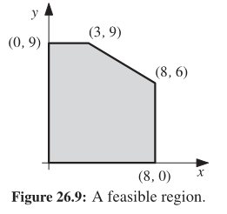  
   1. $z=.6x+y$ should cover both.